**Components Manufacturer Part No Price (£) Quantity Company**

High Speed Infrared Emitting Diode TSFF5210-CS12 0.47 1 VISHAY

Silicon PIN Photodiode BPV10NF 0.64 1 VISHAY

Low voltage fast-switching NPN power transistors 2STX1360 0.124 4 STMICROELECTRONICS

Rail-to-Rail Op Amp MCP6284-E/P 1.35 1 MICROCHIP

Resistor (430 Ω) 0.008 1

Resistor (820 Ω) 0.008 1

Resistor (1.5 kΩ) 0.008 5   
  
Resistors (30 kΩ) 0.028 2

Resistor (120 kΩ) 0.019 1

Resistor (750 kΩ) 0.025 1

Resistor (1.2 MΩ) 0.01 1

Resistor (1.5 MΩ) 0.01 5

Resistor (1.8 MΩ) 0.012 1

Resistor (4.3 MΩ) 0.046 1

Capacitor ceramic (1 µF) 0.065 2

Capacitors electrolytic (10 µF) 0.17 2

BC548 (2N5089G) 0.151 1

TOTAL = £3.851

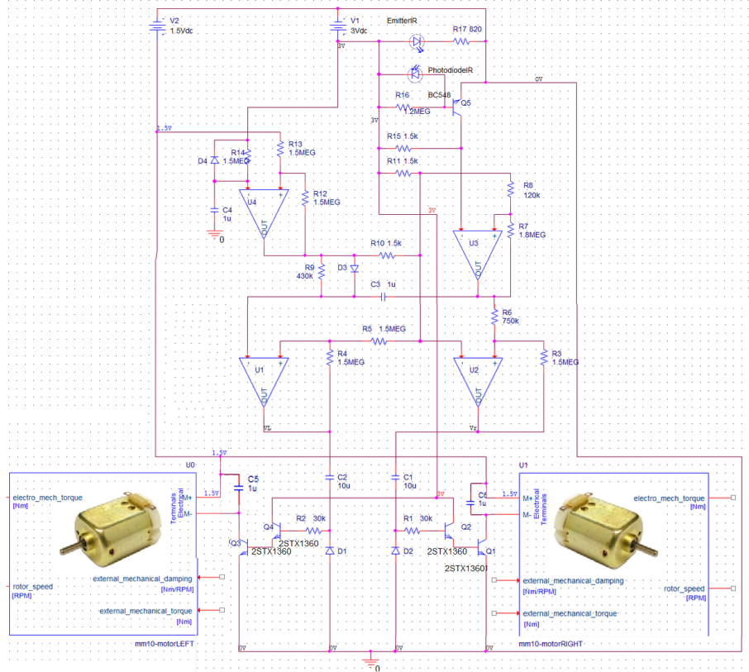

;j ;jkd

Sd’|k\sdkl;g|sdG@